TreeSim
Use Case Diagram

Submitted to:

Prof. Ma. Rowena C. Solamo
Faculty Member
Department of Computer Science
College of Engineering
University of the Philippines, Diliman

Submitted by:
Albano, Romeo Senen D.
Endaya, Jeynald Jeyromme L.
Quiñones, Yzabel Iesa M.

In partial fulfillment of Academic Requirements
for the course
CS 191 Software Engineering I
of the
1st Semester, AY 2014-2015
Revision Control

History Revision:
Revision Date | Person Responsible | Version  Number | Modification
09/12/14 | Romeo Senen Albano  Jeynald Endaya  Yzabel Quiñones | 1.0 | Initial Document.

System Name: TreeSim (Tree Simulator)

Description: TreeSim (Tree Simulator) is an application intended for the Android OS mobile platform that’s especially built for Computer Science students taking undergraduate courses. This application will contain study modules for important topics in the curriculum, such as trees, which aim to further understanding by giving supplementary interactive simulations. Through this application, students can easily find demonstrations of common algorithms, simulators of data structures, and other interactive models of many theoretical concepts. A recommended use of this application would be in a classroom setting where both students and teachers can use it as demonstrations for study.

Use-Case Diagram:

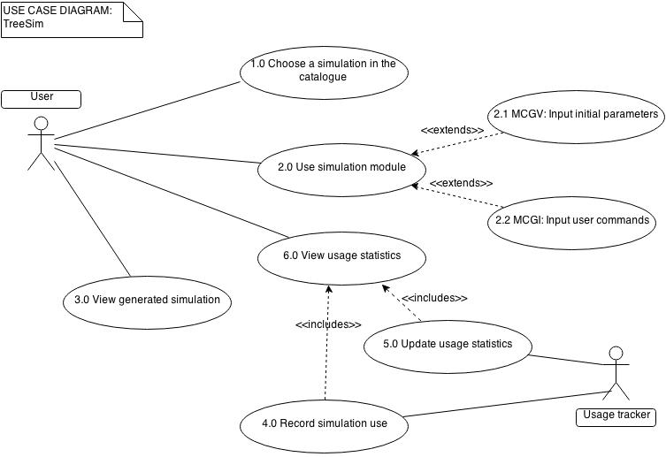

List of Actors:
Actors | Description
User | The intention of the application is to allow the user to view the interactive simulations in order to further their learning. The user can either be a student (for learning purposes) or a teacher (for teaching purposes). The application will allow the student to simulate algorithms and build trees by getting the user input from the student to manipulate the appearance of the tree. In addition, users can view the usage statistics to view how frequent a simulation module is used, which can be a basis for which subjects students find difficult.
Usage tracker | The usage tracker is available in each simulation. Upon access of the simulation, the usage tracker records and updates the usage statistics. This statistics can be viewed by the user.

List of Use-cases:
Use-Case | Description
Use-Case 1.0 Choose a simulation in the catalogue | In this use case, the user is presented with a list of simulation modules. Each item in the list represents an algorithm or a builder for a tree. The user will then choose one simulation module to access.
Use-Case 2.0 Use simulation module | The user inputs all the information needed to run the simulation module. There are two types of simulations in the program: builders (MCGI) and generated videos (MCGV). This is the preparation stage for the actual simulations.
Use-Case 2.1 MCGV: input initial parameters | For the MCGV simulations, this use case is where the user inputs the initial parameters for the demonstration of the algorithm. Parameters can range from choosing a preset tree, to creating a tree as input into the program. The application will inform the user of the needed parameters once they open the simulation.
Use-Case 2.2 MCGI: input user commands | Instructions will be given to the user as they go along this part. For MCGI simulations or the “tree builder” modules, the users will actually continually execute actions. Ideally, they will keep doing this until they’re satisfied and have understood the algorithms involved (such as the deletion of nodes in the tree).
Use-Case 3.0 View generated simulation | Once the user as finished inputting the initial parameters (MCGV) or inputted all commands needed for the tree, the user can view the finished simulation. For the MCGV, this is in the form of “video” or real-time animations. For the MCGI, this is in the form of the finished viewable tree.
Use-Case 4.0 Record simulation use | In this use case, the usage tracker is activated by the user accessing a particular simulation. This recorder tracks the number of times the simulation has been opened as well and the amount of time spent on the simulation in total for each of the modules. While these measurements do not directly indicate whether the user finds the topic hard, they can still be good indicators.
Use-Case 5.0 Update usage statistics | The usage tracker collects all the statistics from the different simulation modules into one centralized document. This document is known as the usage statistics document, and this is actually the file displayed whenever the user views the usage statistics. Whenever the users run simulation modules, the usage tracker maintains and updates the usage statistics document.
Use-Case 6.0 View usage statistics | The user (students or teachers) can choose to view their usage statistics document in the program. This document contains data such as the amount of times the user has used a particular simulation, how much total time they’ve spent on it, etc. Take note that this document only measures local usage. It will only measure the way the application is being used on the device it is on (ie. No online databases).

